- Project development phase1:
- Data Collection
  - Collected the Product Placement dataset from the source and imported it into Tableau.
- Handling Missing Values
  - Identified missing values and removed or replaced them to ensure data quality.
- Removing Duplicate Records
  - Removed duplicate entries to avoid incorrect analysis.
- Data Cleaning
  - Corrected inconsistent values, fixed formatting issues, and standardized category names.
- Data Type Conversion
  - Converted fields such as Sales, Profit, Quantity, and Date into appropriate data types.
- Data Transformation
  - Created calculated fields and organized the dataset for better visualization.
- Outlier Detection
  - Identified unusual values that could affect the analysis and handled them appropriately.
- Data Validation
  - Verified that the cleaned dataset was accurate and ready for visualization.
- Data Visualization Preparation
  - Prepared the processed data for creating dashboards, charts, KPIs, and filters in Tableau.
- Final Dataset
- The cleaned and transformed dataset was used to generate insights for product placement analysis and business decision-making.
Strategic Product Placement Analysis – Business Questions with visualizations
Business Question
1. Which product category has the highest average sales volume?
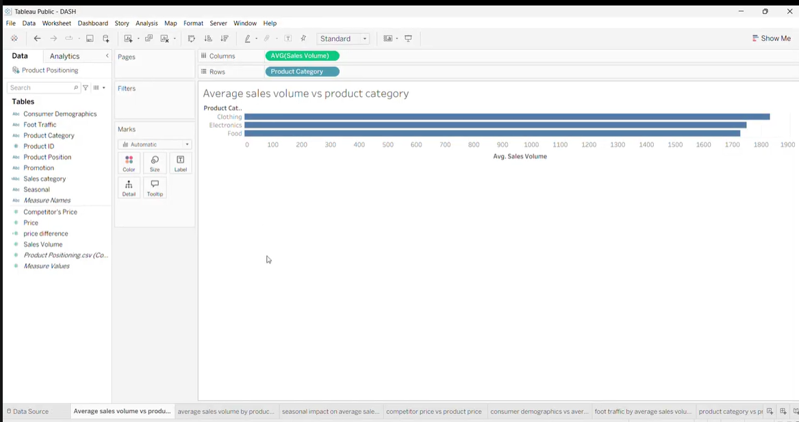
2. How does product position affect average sales volume across product categories?
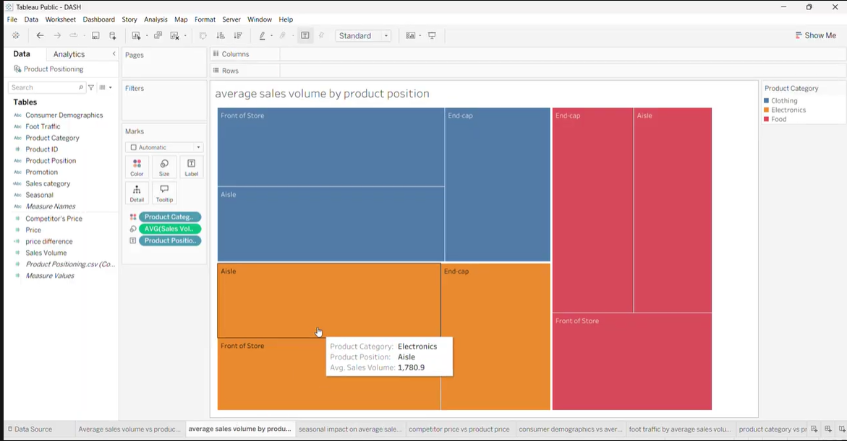
3. Which season generates the highest average sales volume for each product category?
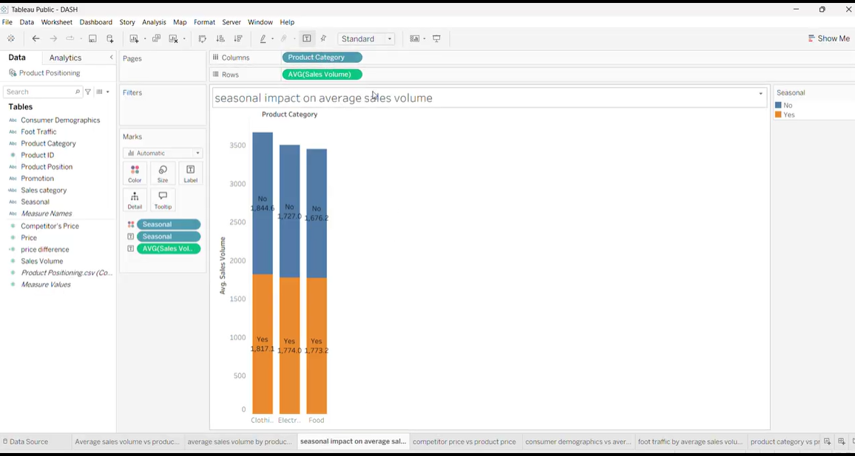

4. How does competitor price influence our product price?
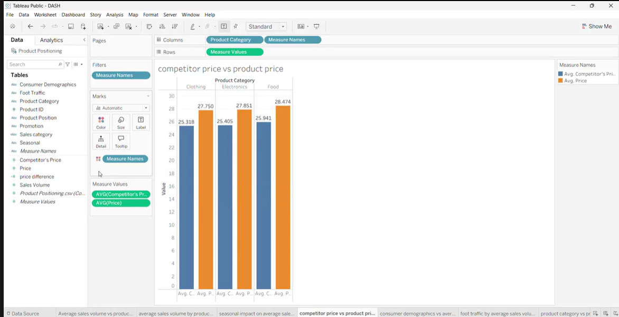

5. Which consumer demographic contributes the highest sales volume?
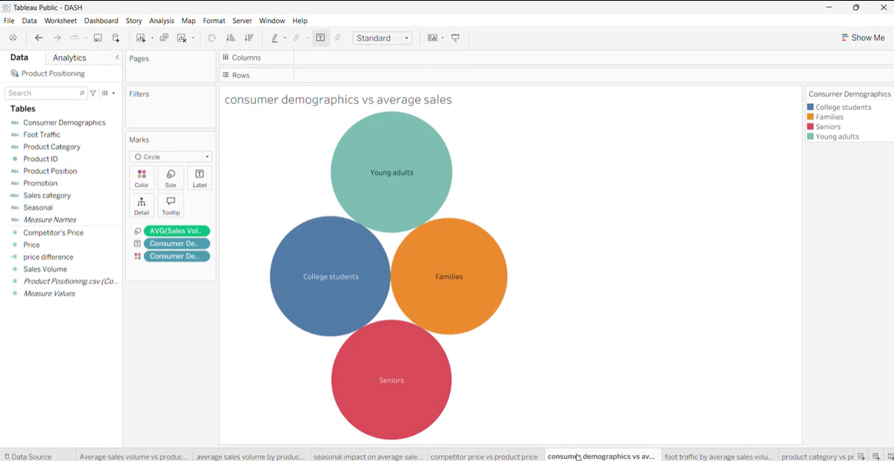
6. Does higher foot traffic result in higher average sales volume?
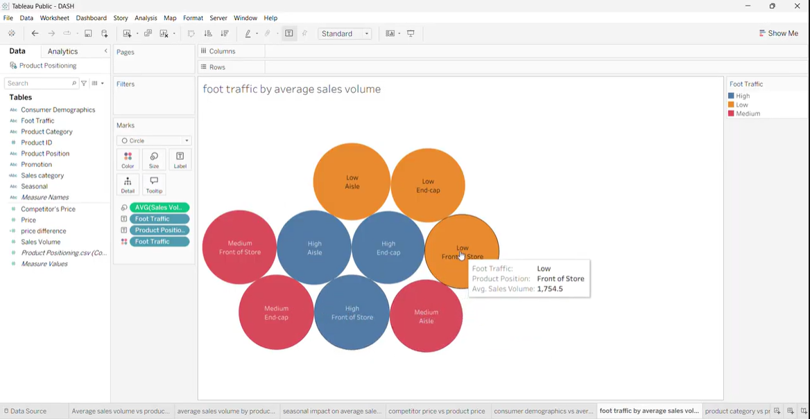
7. How does product category influence product pricing?
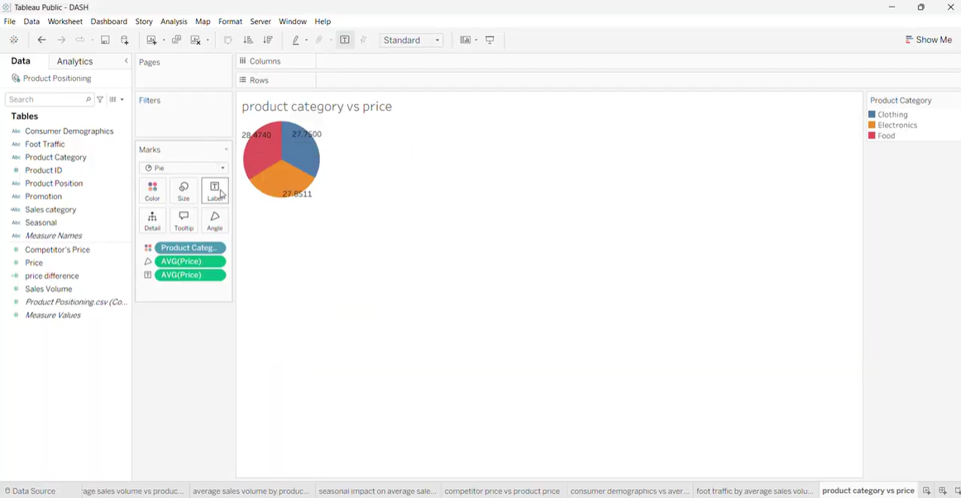

8. How do promotions affect product price and sales volume?
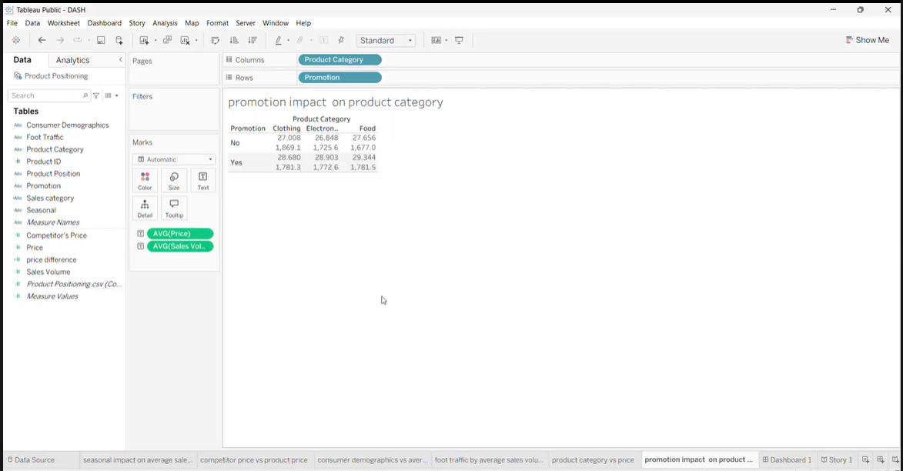

- Full Dashboard Screenshot
